# ***Comprehensive guide on how to install on windows***

MySQL

Go to the [MySQL Community Downloads page](https://dev.mysql.com/downloads/installer/).

Choose the appropriate installer for your operating system (Windows, macOS, or Linux).

I installed under windows.

On Windows, run the .msi installer.

Select the setup type. For most users, the "Developer Default" is recommended as it installs MySQL Server, MySQL Workbench, and other useful tools.

The installer will check for requirements and install any missing dependencies.

Proceed with the installation steps, including configuring the server.

Set a strong root password. Optionally, create additional users.:

Choose the server configuration type (Development Machine, Server Machine, or Dedicated Machine).

Configure networking options and specify the port (default is 3306).

Optionally, enable MySQL as a Windows Service

Finish the installation process. MySQL Server and Workbench should now be installed on your system.

When I finished installing MySQL I noticed that MySQL workbench had not downloaded with it so I went on the MySQL download website

https://dev.mysql.com/downloads/windows/installer/5.7.html

where I clicked on the Workbench download, which took me to the downloading page, where I selected the version suitable for my laptop and clicked download and it successfully downloaded.

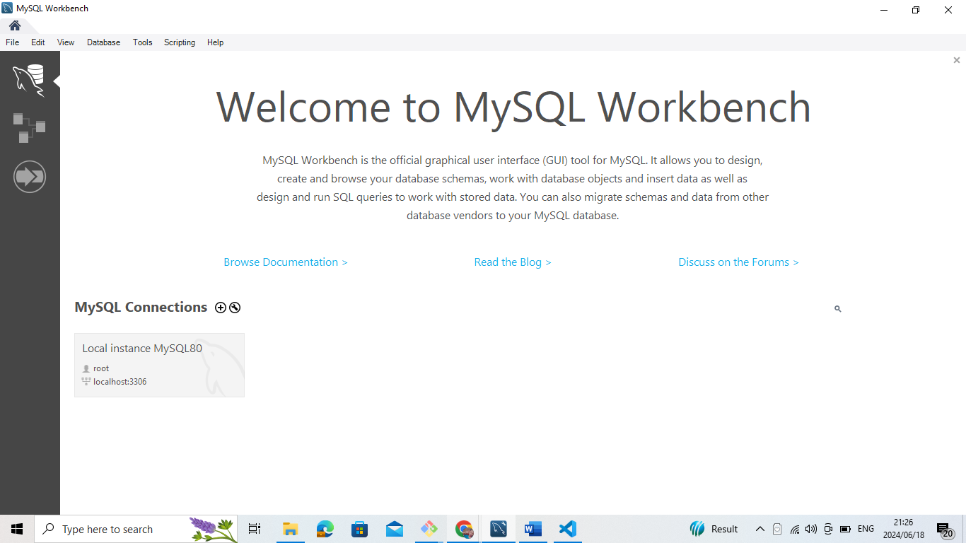

Git and GitHub

**Download Git for Windows**:

* Go to the [Git for Windows download page](https://git-scm.com/download/win) and download the latest version of Git.

**Run the Installer**:

* Double-click the downloaded .exe file and follow the installation steps. Choose the default options unless you have specific needs.
* During the installation, you can choose a text editor (like Vim, Notepad++, or VS Code) and configure other settings like the initial branch name, line ending conversions, and additional PATH options.

**Verify Installation**:

Open Command Prompt and run:

git –version

Configure Git

Set Up Your Identity:

Configure your name and email address. These details will be associated with your commits.

git config --global user.name "Your Name"

git config --global user.email "your.email@example.com"

Check Configuration:

To verify your settings, run:

git config --list

Step 3: Create a GitHub Account

Sign Up for GitHub:

Go to the [GitHub website](https://github.com/) and click "Sign up".

Follow the instructions to create a new account.

Create a .gitignore File

Create .gitignore:

In your repository directory, create a .gitignore file to specify files and directories to ignore:

touch .gitignore

Add Patterns to .gitignore:

Open .gitignore in a text editor and add patterns for files and directories to ignore:

__pycache__/

*.pyc

*.pyo

.env

.vscode/

node_modules/

Stage and Commit .gitignore:

Stage and commit the .gitignore file:

git add .gitignore

git commit -m "Add .gitignore file"

git push origin main

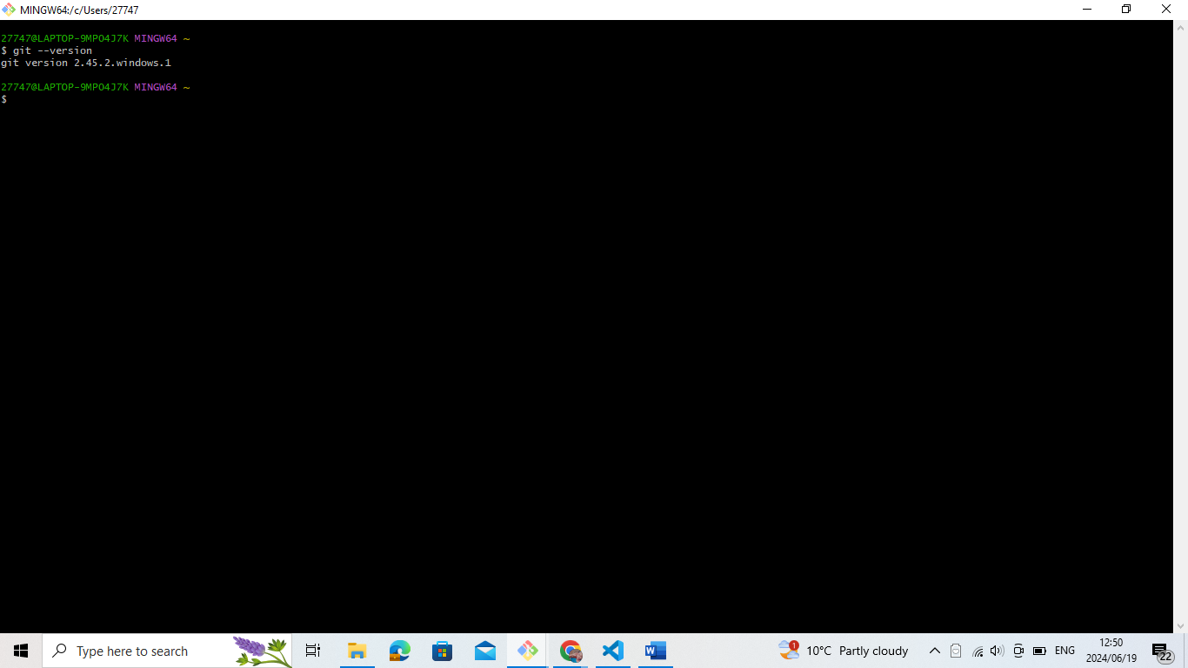

Python

Download Python: Go to the python.org and download the latest version of Python.

Install Python: Run the installer. Make sure to check "Add Python to PATH" during installation.

Verify Installation: Open a terminal or command prompt and run:

python –-version

You should see the Python version number.

Visual Studio Code

Download VS Code: Go to the [Visual Studio Code download page](https://code.visualstudio.com/Download) and download the installer for your operating system.

Install VS Code: Run the installer and follow the on-screen instructions.

Launch VS Code: Open VS Code after the installation is complete.

Dart

Download Dart SDK:

Go to the Dart SDK download page.

Download the Dart SDK installer for Windows.

Run the Installer:

Run the downloaded installer and follow the on-screen instructions.

Set Environment Variables:

Open Control Panel -> System and Security -> System -> Advanced system settings.

Click on "Environment Variables".

Under "System variables", find the Path variable, select it, and click "Edit".

Add the path to the Dart SDK (e.g., C:\dart\dart-sdk\bin) and click "OK".

Verify Installation:

Open a new Command Prompt and run:

dart --version

You should see the Dart version number.

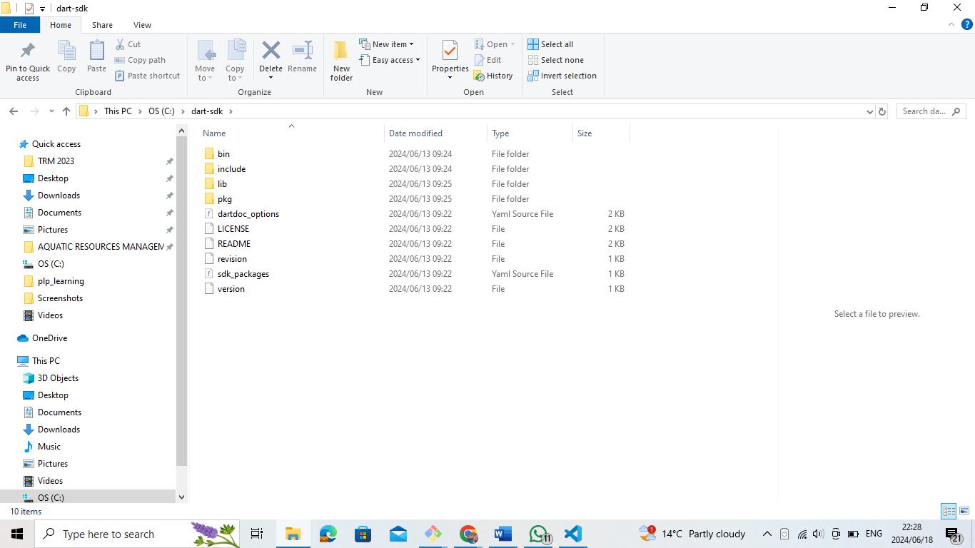

Flutter

Download Flutter SDK:

Go to the Flutter SDK download page.

Download the latest Flutter SDK zip file.

Extract the SDK:

Extract the zip file and place the flutter directory in a desired location (e.g., C:\src\flutter).

Set Environment Variables:

Open Control Panel -> System and Security -> System -> Advanced system settings.

Click on "Environment Variables".

Under "System variables", find the Path variable, select it, and click "Edit".

Add the path to the Flutter SDK (e.g., C:\src\flutter\bin) and click "OK".

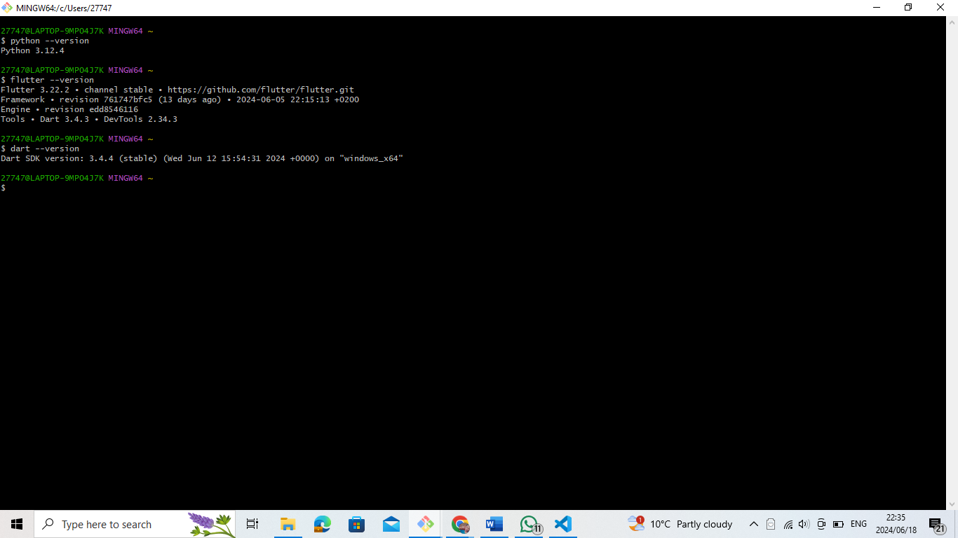

Problems I have encountered while installing the applications.

Visual Studio Code

Compatibility of Extensions: Occasionally, I install Visual Studio Code extensions that don't work with the version of VS Code I'm using. Crashes or other problems with functionality may result from this. I usually make sure that extensions work with the version of VS Code I'm using before adding them to prevent problems.   
Workspace Configuration: From time to time, I have problems with the settings in VS Code for my workspace. This typically occurs when there are incompatible extensions or competing settings. When this happens, I try to restore normal functionality by either removing conflicting extensions or resetting my workspace settings.  
Update Errors: Occasionally, Visual Studio Code upgrades don't install correctly. Incomplete downloads or network outages may be the cause of this. I manually download and reinstall the update from the VS Code website in order to fix this, making sure that my internet connection remains steady throughout.

***Strategies to Overcome Challenges***

**Use Virtual Environments**: Always use virtual environments (venv) to manage dependencies and avoid conflicts with global packages.

**Consult Documentation**: Make use of the official documentation and community forums for troubleshooting and best practices.

**Stay Updated**: Regularly update your software to the latest versions to benefit from bug fixes and new features.

Common Challenges For GIT

*Permission Issues:*

Problem: Lack of permissions for Git operations.

Solution: Use elevated privileges (e.g., sudo on Linux/macOS or run as administrator on Windows) or configure SSH keys for secure authentication.

*Conflicts During Merge:*

Problem: Conflicts when merging branches.

Solution: Carefully review and resolve conflicts using Git's conflict resolution tools. Communicate with team members to avoid simultaneous conflicting changes.

*Large File Handling:*

Problem: Managing large files in a repository.

Solution: Use Git LFS (Large File Storage) to handle large files efficiently.

git lfs install

git lfs track "*.psd" # Example for tracking Photoshop files

git add .gitattributes

*Repository Organization*:

Problem: Keeping the repository organized.

Solution: Follow best practices for repository structure, use descriptive commit messages, and maintain a clean and consistent workflow.

**Strategies to Overcome Challenges**

*Regular Commits:*

Commit changes frequently with clear and descriptive messages to maintain a well-documented history.

*Branching Strategy:*

Use branches for new features, bug fixes, and experiments. Merge changes to the main branch after thorough testing.

*Code Reviews:*

Conduct code reviews to maintain code quality and facilitate knowledge sharing within the team.

*Continuous Learning*:

Stay updated with Git and GitHub features and best practices through documentation, tutorials, and community forums.